### CS-639 Building User Interfaces, Fall 2019, Professor Mutlu

# Assignments — Week 03 | Design | Visual Design

In this assignment, you will practice using the visual design elements and principles you learned in class. Remember that the best way to sharpen visual design skills is to create checklists of elements, principles, and rules of thumb and to apply them to both analyze existing designs and to devise new designs. In the assignment, you will use a checklist provided and will practice both. To complete the assignment, you will identify an existing web page, such as a commercial product page, a home page of an individual or institution, or a portal (e.g., news, forums), first analyze the design to identify what elements are used and what principles are followed and violated. You will then redesign the page to apply visual design principles, justifying your choice and application of the principles.

### Checklist

**Step 1. Study the Checklist.** Review the checklist below and what they represent from lecture slides and your notes from class. Internalize them such that you can immediately think of examples for each element/principle. Remember that elements are raw materials, and principles are ways of applying them. For elements, when you are looking at designs, ask the question, “what is this made of;” and when you are designing, ask, “what should I use here?” For principles, when you analyzing designs, ask the question, “where is the focal point;” and when you are designing, ask, “how should I direct user attention to important elements?” In the future, as a designer, you should create your own list with your set of elements, principles, and rules of thumb.

|  |  |  |  |
| --- | --- | --- | --- |
|  | **Elements of Design** |  | **Principles of Design** |
|  | Space |  | Focal point |
|  | Line |  | Contrast |
|  | Shape |  | Balance |
|  | Size |  | Movement |
|  | Pattern |  | Rhythm |
|  | Texture |  | Perspective |
|  | Value |  | Unity |

### Target

**Step 2. Identify a target page.** Identify an existing web page, such as a commercial product page, a home page of an individual or institution, or a portal (e.g., news, forums), to analyze and redesign in this assignment. If the page a lot of content, such as infinite scroll, focus on “above the fold” (the part of the page that you see in your browser without scrolling). Provide a link to the page below and describe in a couple of sentences on why you chose this particular page for the assignment.

<https://www.instructure.com/>

First I thought of doing canvas since it is something we see daily, then I stumble upon the company that made canvas and thought that the page looked clean and nice. I really like the minimal design of the page, however, that is not to say that the page is without much design at all.

### Analyze

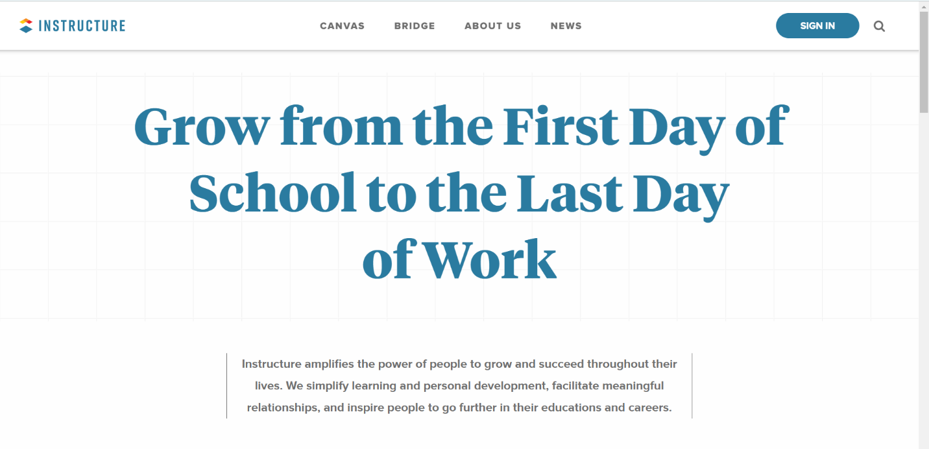**Step 3. Analyze the current design.** In this step, you will analyze the current design by taking a screenshot of the current design and annotating it to highlight design elements and how the design principles are used. You can take a digital screenshot of the design and annotate it digitally, or printout the page, annotate it on paper, and include a photo of your annotation below. To capture the current window, on Windows, you can press “Alt + PrtScn” or “Alt + Fn + PrtScn.” On the Mac, you can press “Command + Shift + 4” and then spacebar. In your analysis, first make a pass for all the design elements you see. Are there lines on the page? What shapes are used? Is a pattern used? How is space used? Is it positive or negative? Then make a pass for the design elements. See if the page has a clear focal point, whether there is clear use of contrast, to what extent the page has unity, and so on. Principles can be applied successfully or poorly—identify both good and bad uses. Remember to use your checklist.

Grid patterned background resembles sketch pads to evoke emotions in user or show texture

There is a focal point on the center quote of the page since the size is so huge that it is impossible to ignore.

The lines pull or calls the user attention to the next paragraph to read.

* not much contrast in the page hence

the only one in the page would be the focal point

* background has weak value and is hard to see
* grid motif gives a sense of unity and binds the whole page together.

### Design

**Step 4. Redesign.** Next, you will redesign the page you analyzed with the goal of improving its visual design. First consider what elements you must place on the canvas. All elements should have a function. If the original design included elements with no function or use, you can exclude them in your redesign. Next, consider the design principles, and ask yourself, “how can I direct user attention appropriately,” “do I need to create contrast between elements,” “how do I achieve unity,” and so on. You will need to go back and forth between the elements and principles. For example, you must determine what user attention should be directed to, such as a product photo, a button, or a paragraph of text, in order to place the focal point to it. Similarly, you should think about the composition of elements to create an appropriate level of balance on the page. Your redesign should be in the form of a digitally- or hand-drawn wireframe with annotations that justify the use of the elements and principles.

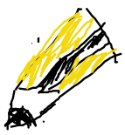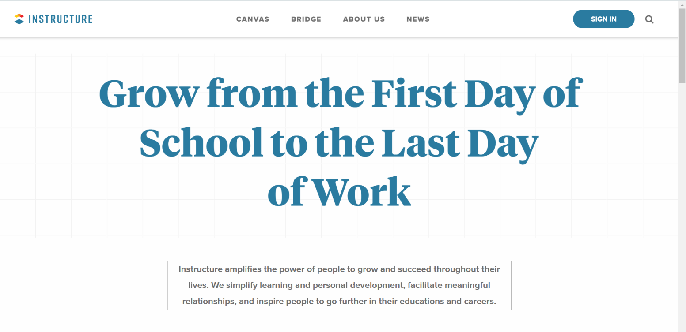



* Make the grid more visible and have more value
* Put the quote in a post-it note image to give more emphasis
* Make the note a focal point by pointing the eraser and pencil towards it
* Fold the edge of the note to give it more depth to the perspective.
* Shapes of objects used would give the whole theme a sense of unity
* Different height levels of the pencil and eraser, and the pencil on the right(right-handed), changes the sense of balance of the image.

### Color & Type

**Step 5. Specify color and type choices.** Finally, determine what color palette your redesign should follow. How many colors/shades will you use? Why will use these colors? Keep design principles in mind when you are choosing colors. For example, using contrasting colors, you can create contrast and manage user attention. Additionally, determine what category of typeface and what font you will use, whether or not you will use multiple fonts on the page, and how you will parameterize each font. You may review the fonts in your computer’s fonts folder (on Windows, go to “My Computer > Control Panel > Fonts” and select “View > Details;” on the Mac use the Font Book app) or the [Google Fonts collection](https://fonts.google.com) to give you ideas and get familiar with available typefaces.

More pastel types of colors and the objects “true” colors that would incite a sense of nostalgia.

White background for purity of text or paper.

Not a lot of colors for cleanliness.

For fonts, we can give more unity by using a font similar to a rough pencil: Bradley Hand ITC

The hand-written style also gives it a more organic shape.

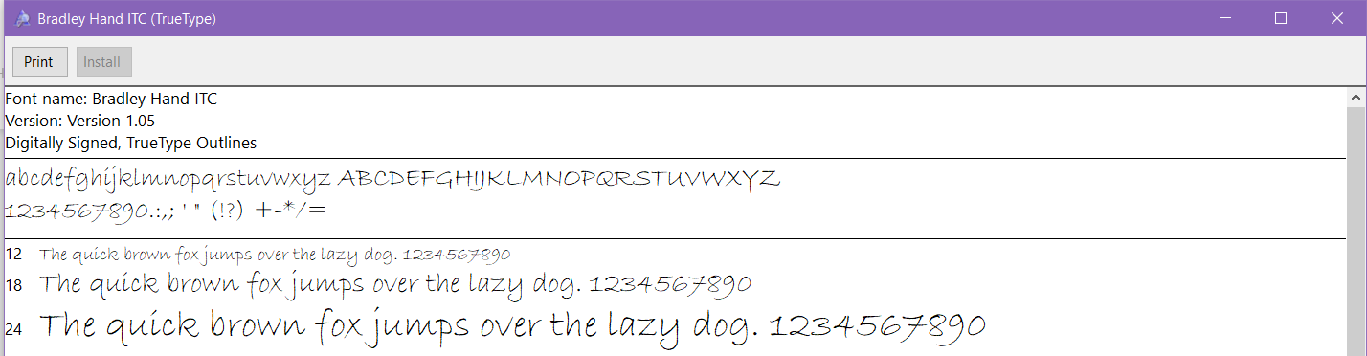Other than the top banner, there would not be multiple fonts since the font I chose is easy on the eyes to read.

The top banner should be kept as is because I feel like the original design gives it a sense of professionalism.